**Digital sign in pdf(Initally Unveriffied tick)**

In many of the Government portals we observe that the Document generated is inaitally not verified and it has a Question Mark on this. Once it is approved by any PDF viewer by adding it to trusted document and verifying it. So Idea is to Generate similar kind of pdf using Mendix where along with the respective data we can see the Unverified stamp. And let user validate it and use it later.

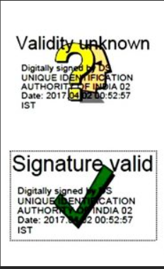  
  
Approches :  
1. Used [Sign Easy](https://marketplace.mendix.com/link/component/120382) tool to create this kind of validation but failed to create the digital signature like this.This module can be used to create digital signature to fill and can be send to emails as well.

2. I used [Pdf Fill Form Fields](https://marketplace.mendix.com/link/component/116692) and [DocuSign Connector,](https://marketplace.mendix.com/link/component/112333) these are also like sign easy where it failed to create Validation Digital signatures.   
  
references used to implement   
  
1. [Mendix Forum - Question Details](https://forum.mendix.com/link/space/usability/questions/124304)

2.[Signature | Mendix Documentation](https://docs.mendix.com/appstore/widgets/signature/)

3.[Mendix Forum - Question Details](https://forum.mendix.com/link/space/widgets/questions/87573)

4. [Integrating Mendix with DocuSign: Move from Paper to e-Signatures - YouTube](https://www.youtube.com/watch?v=S2eV4fmPplE)

Future suggestion:  
1. It should be possible by using some API or implementing it scrach .